## BCDR

## Feedback Summary

### Milestone 2

#Login

* See example mockup – should look the same  
  Please insert the logo directly here and not like a profile picture with a round frame - the picture should be fixed like in the picture.  
  please recreate the design as far as possible and generally adapt the blue tones to our logo. (see example)

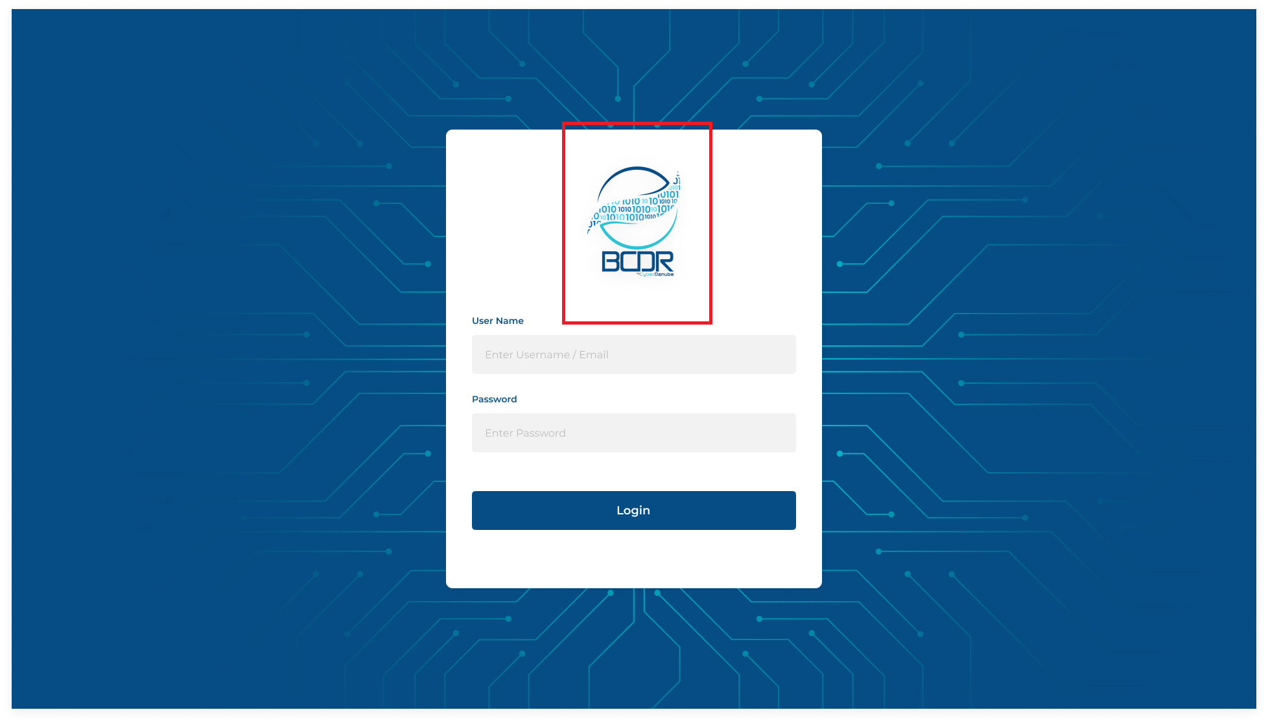

we will send you the background file / export separate. see followed the .png screenshot.



#Inventory

* Dashboard and inventory is quite the same. In the "Inventory" area, the graphics are not necessary, because those in the dashboard are primarily intended to be evaluated graphically.  
  Therefore, in the "Inventory" area, the focus should be on data collection from the 4 areas Legal Entity, Office, People and Assets in form of a list/table.   
  Our suggestion would be to mark each area as we did with the four large tabs on the top. Afterward the table is then dynamically loaded and displayed below.  
  See example Picture:

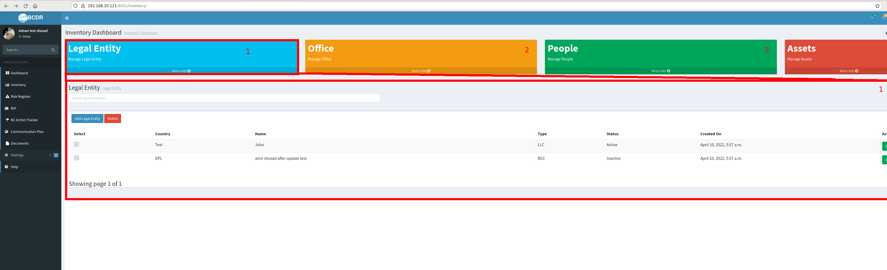

The overall design should basically look exactly like the following picture on the right. (simply snipped together with Paint as an example)

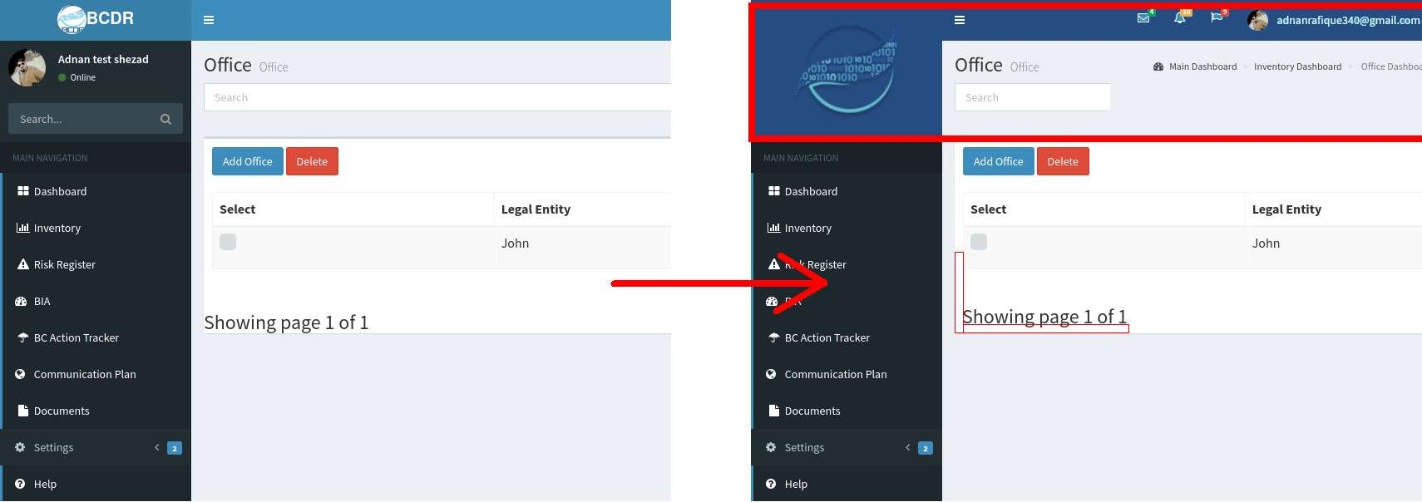

Please generally use different shades of blue or gray for the graphics (no light green, orange, ...). That means consistent/coherent colors to the rest of the website. See example attached.

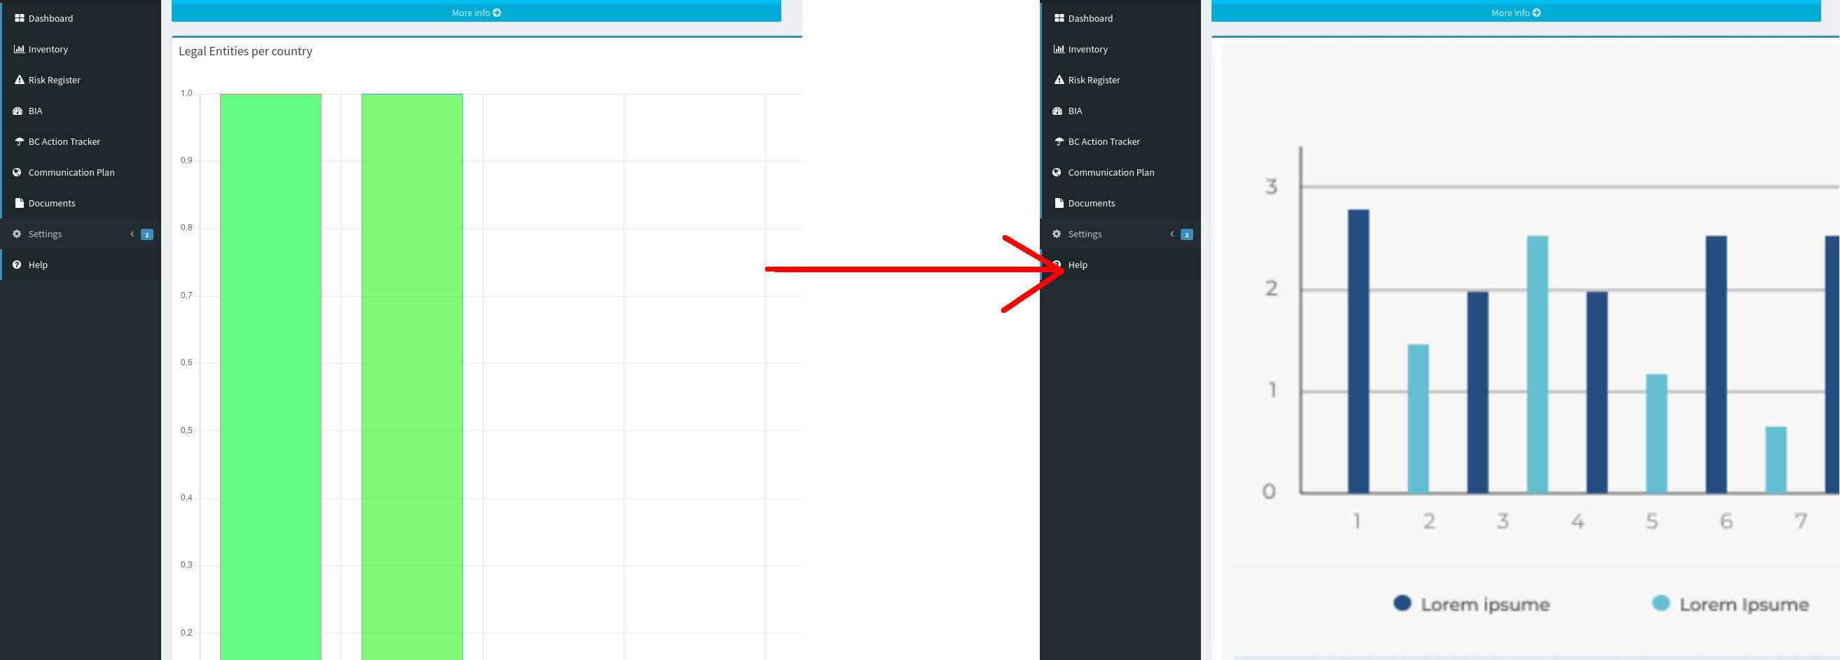

if a table bellow changes to the next worksheet “2”, for example, the second table also changes at the same time to “2”. However, it should be possible to scroll through both tables independently of one another.

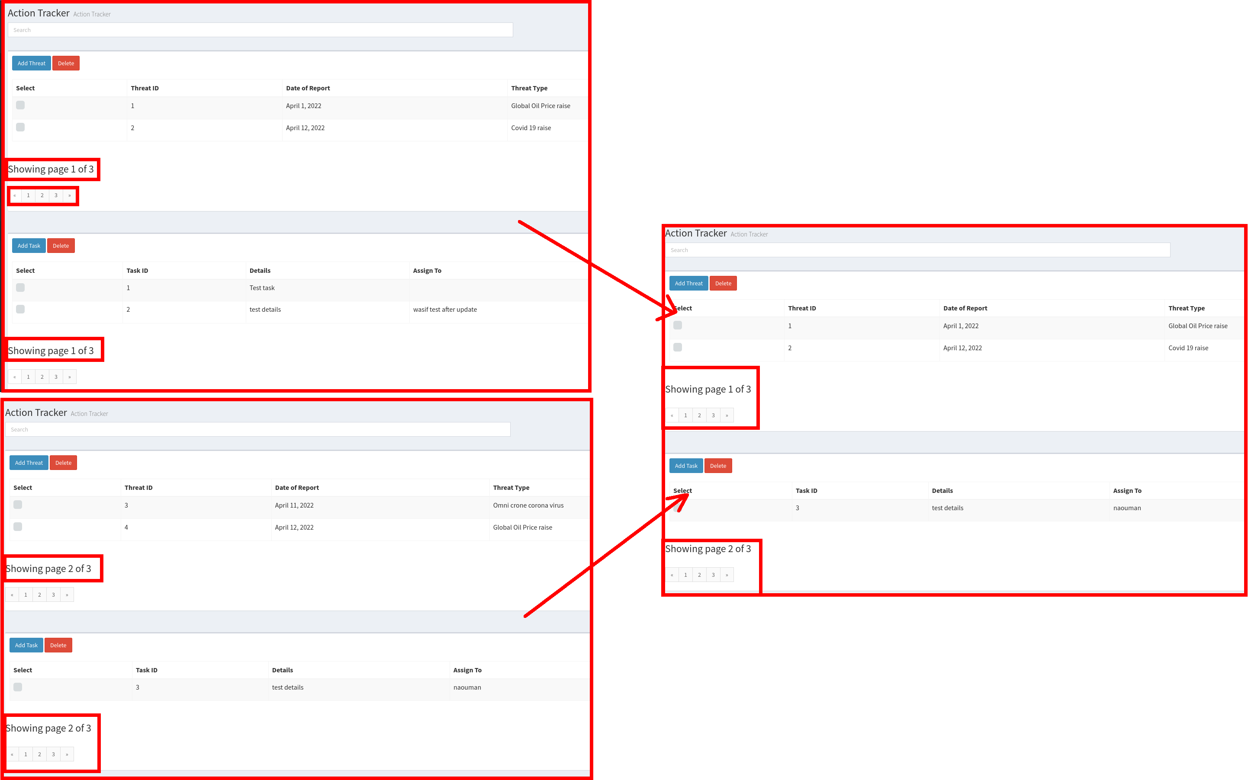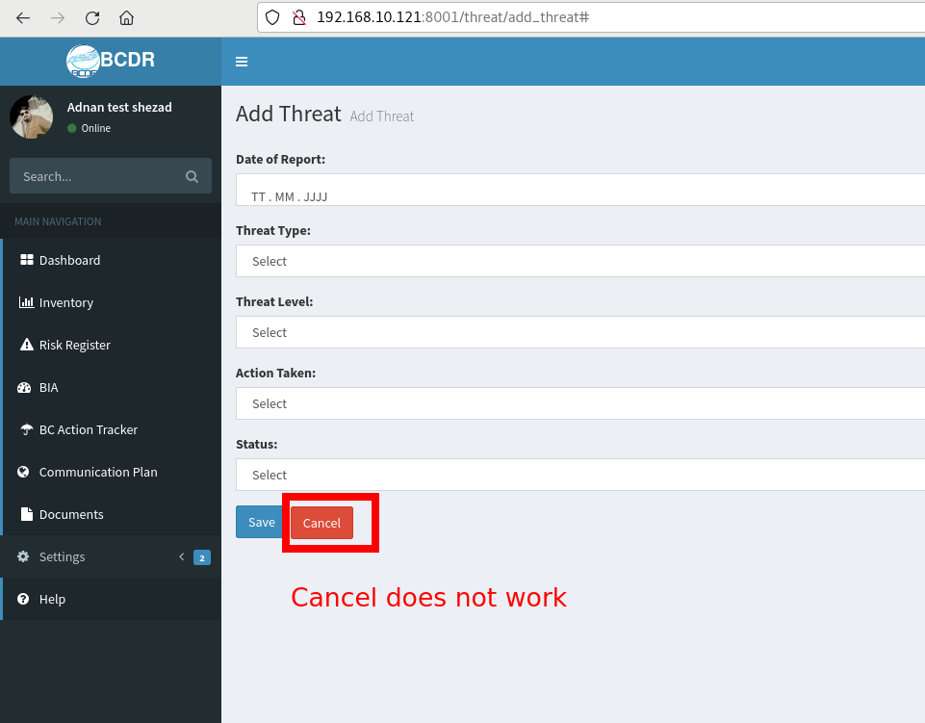

Add Person should be changed to “Add Assets” in tab Asset:

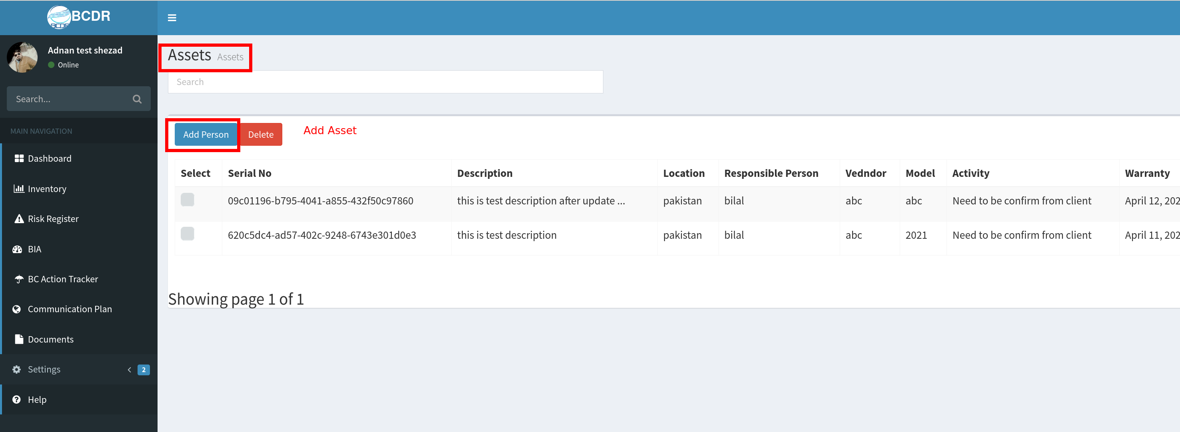

“Dashboard” e.g. in the tab of the browser should always have the title “Business Continuity Disaster Recovery | Dashboard” (the same should be done for “Inventory, Communication Plan, BIA, ...)

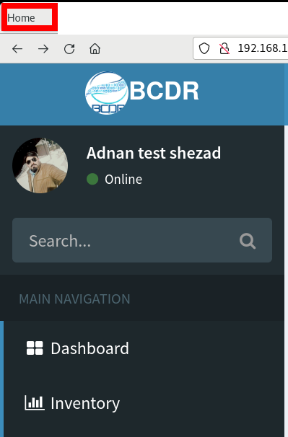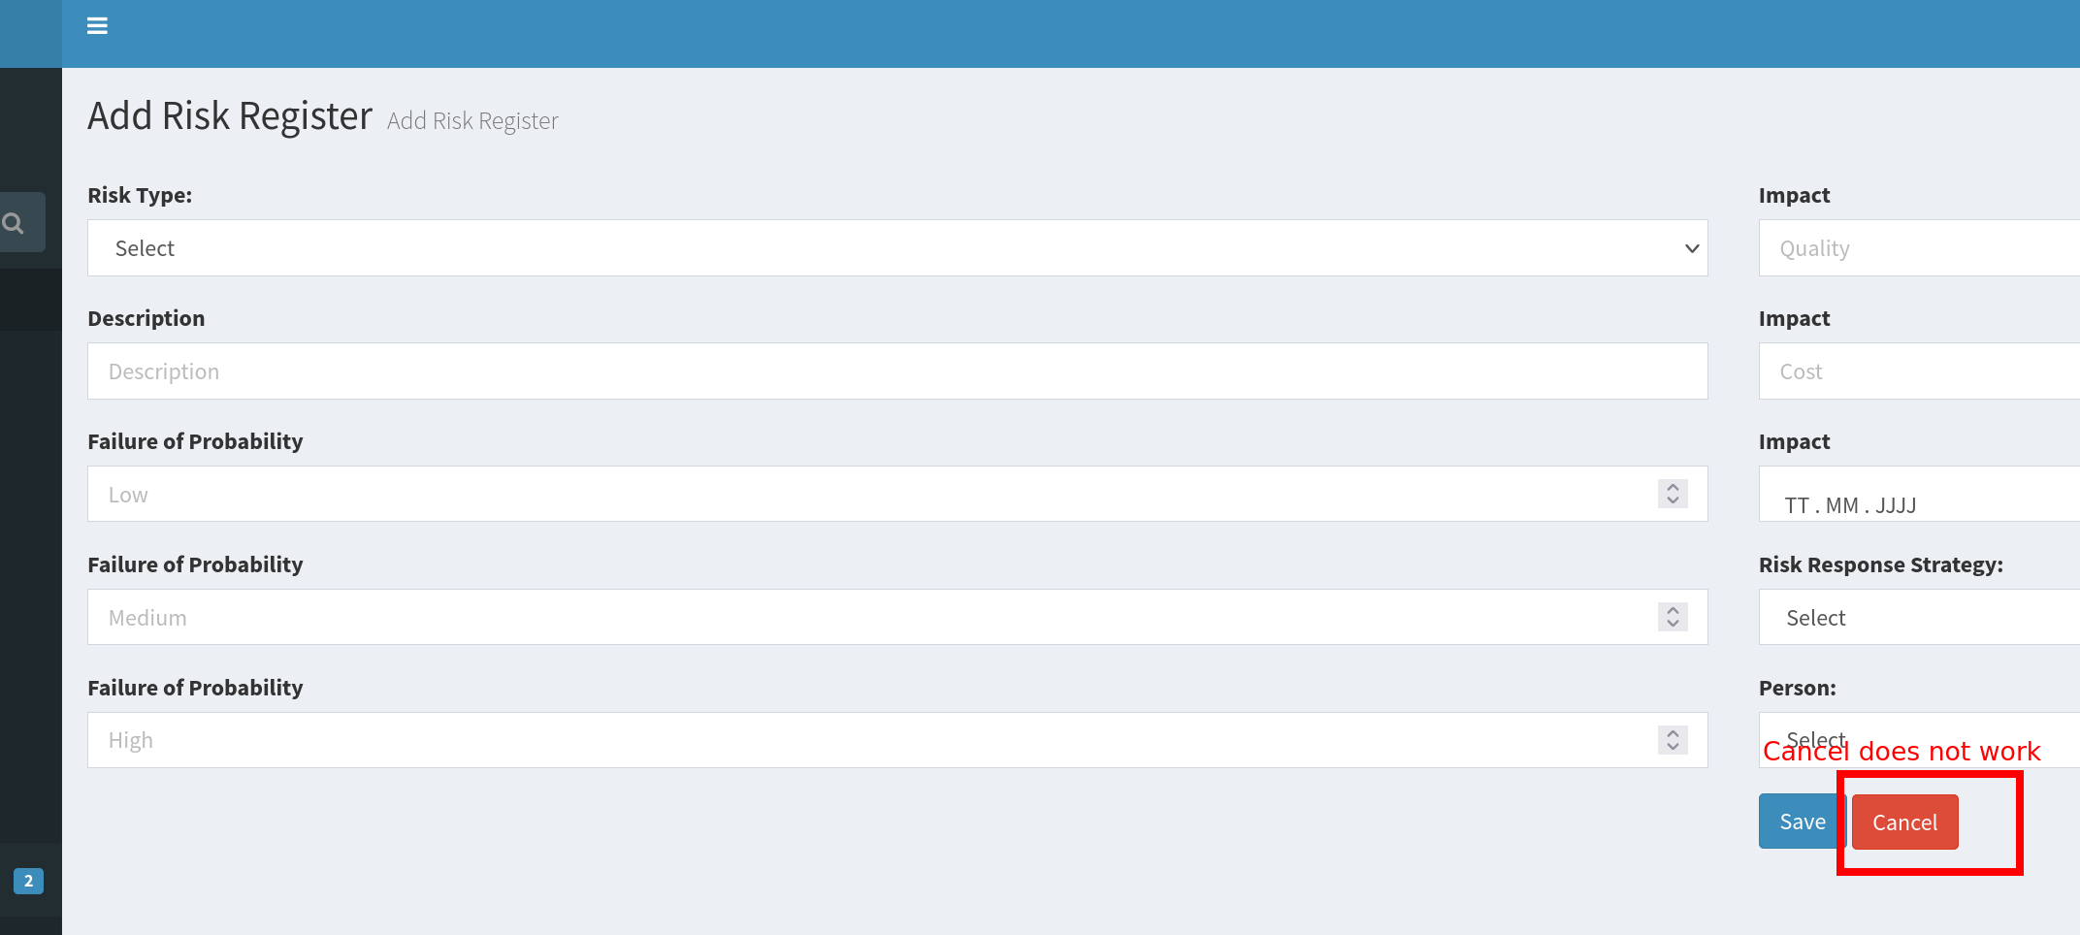

"Skins" can be changed in the settings - this is not relevant for our project and should better be fixed statically in the colors (blue tones), as noted.

Two skins are necessary - one BCDR skin with a blue tone - and one dark mode for the night.

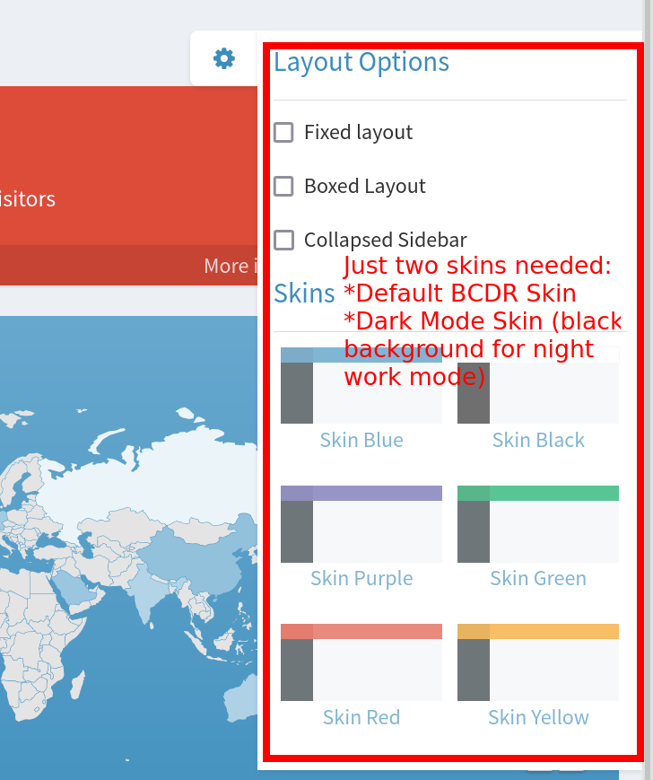

We find the dashboard very appealing and it comes very close to what we imagined. (e.g. the "Sales" graph or the "Visitor" map with the blue tones hits the design well - we only have to adapt the content well and sensibly (change source data and text))

We will come back to you in detail in the next milestones.

### Milestone 3

The information "Showing Page 1 of 4" should be displayed much smaller and less prominently on all the pages like on this one. The page number tabs should also be displayed much smaller and more discreetly.

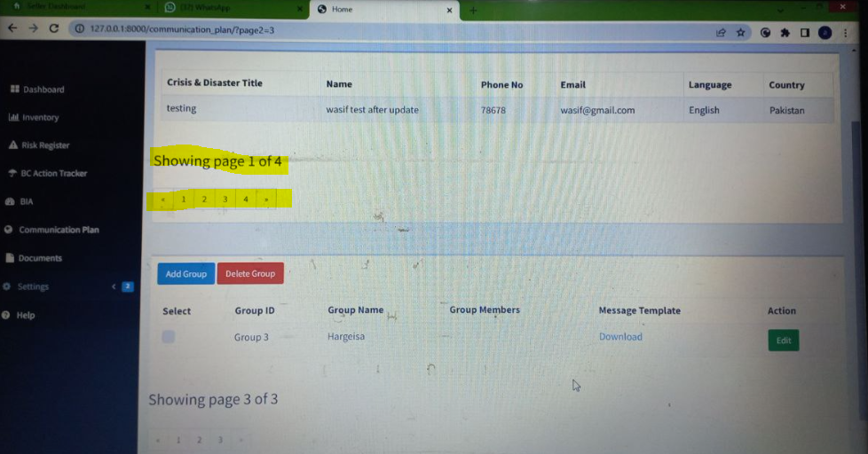

Login Page 1 and second screen of login page (verification of MFA) should have the same design (background).

(as discussed in our last meeting 21.04.2022 you will redesign / work on the background)

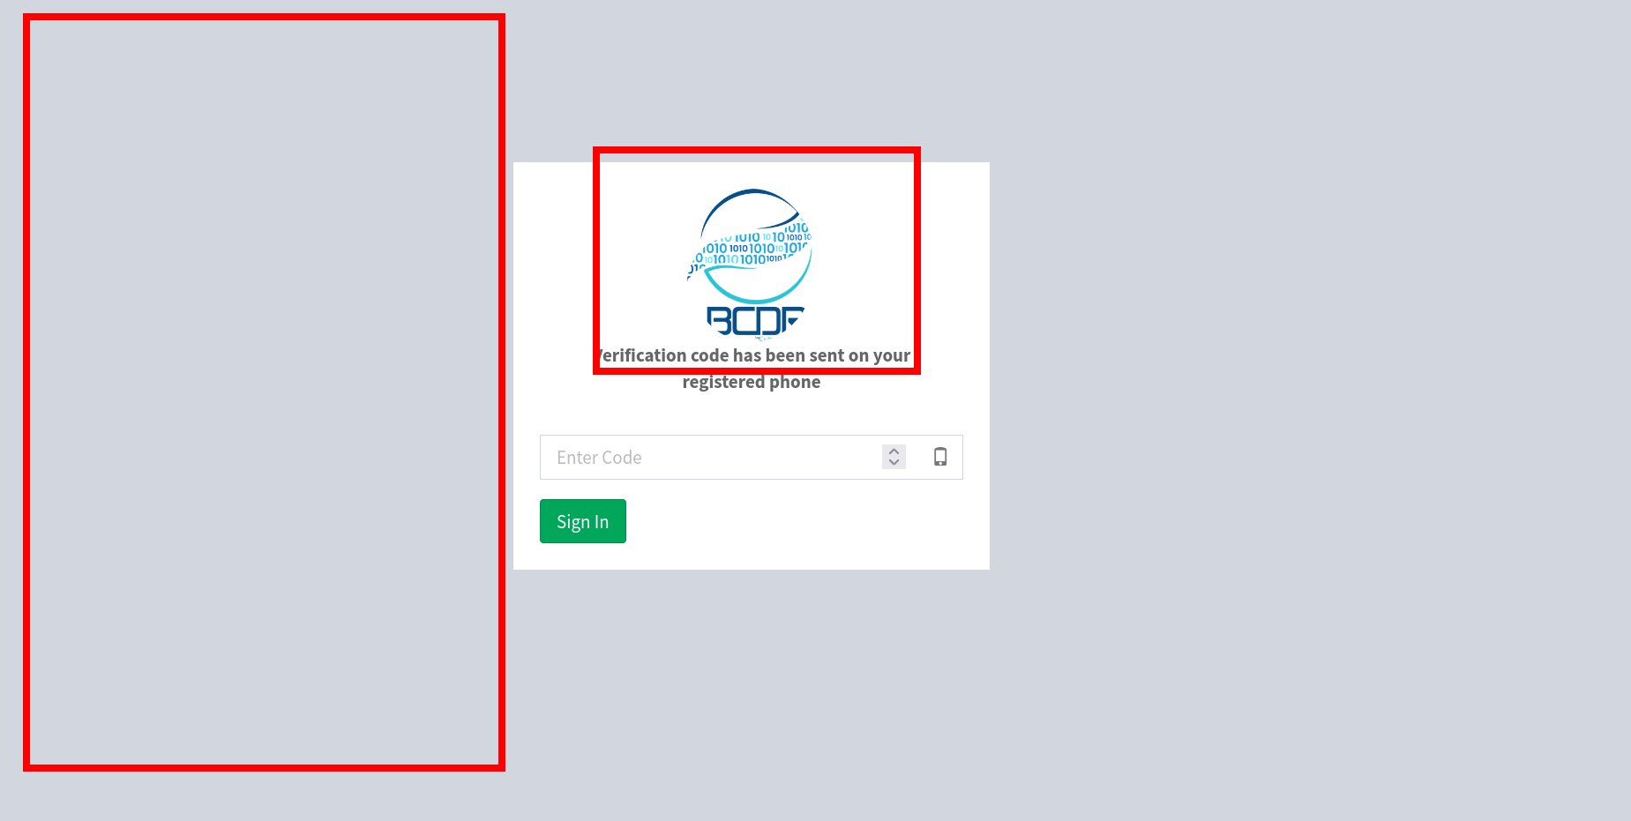

The length and spacing of the lines/tables should be static and not dynamically shift based on the content.

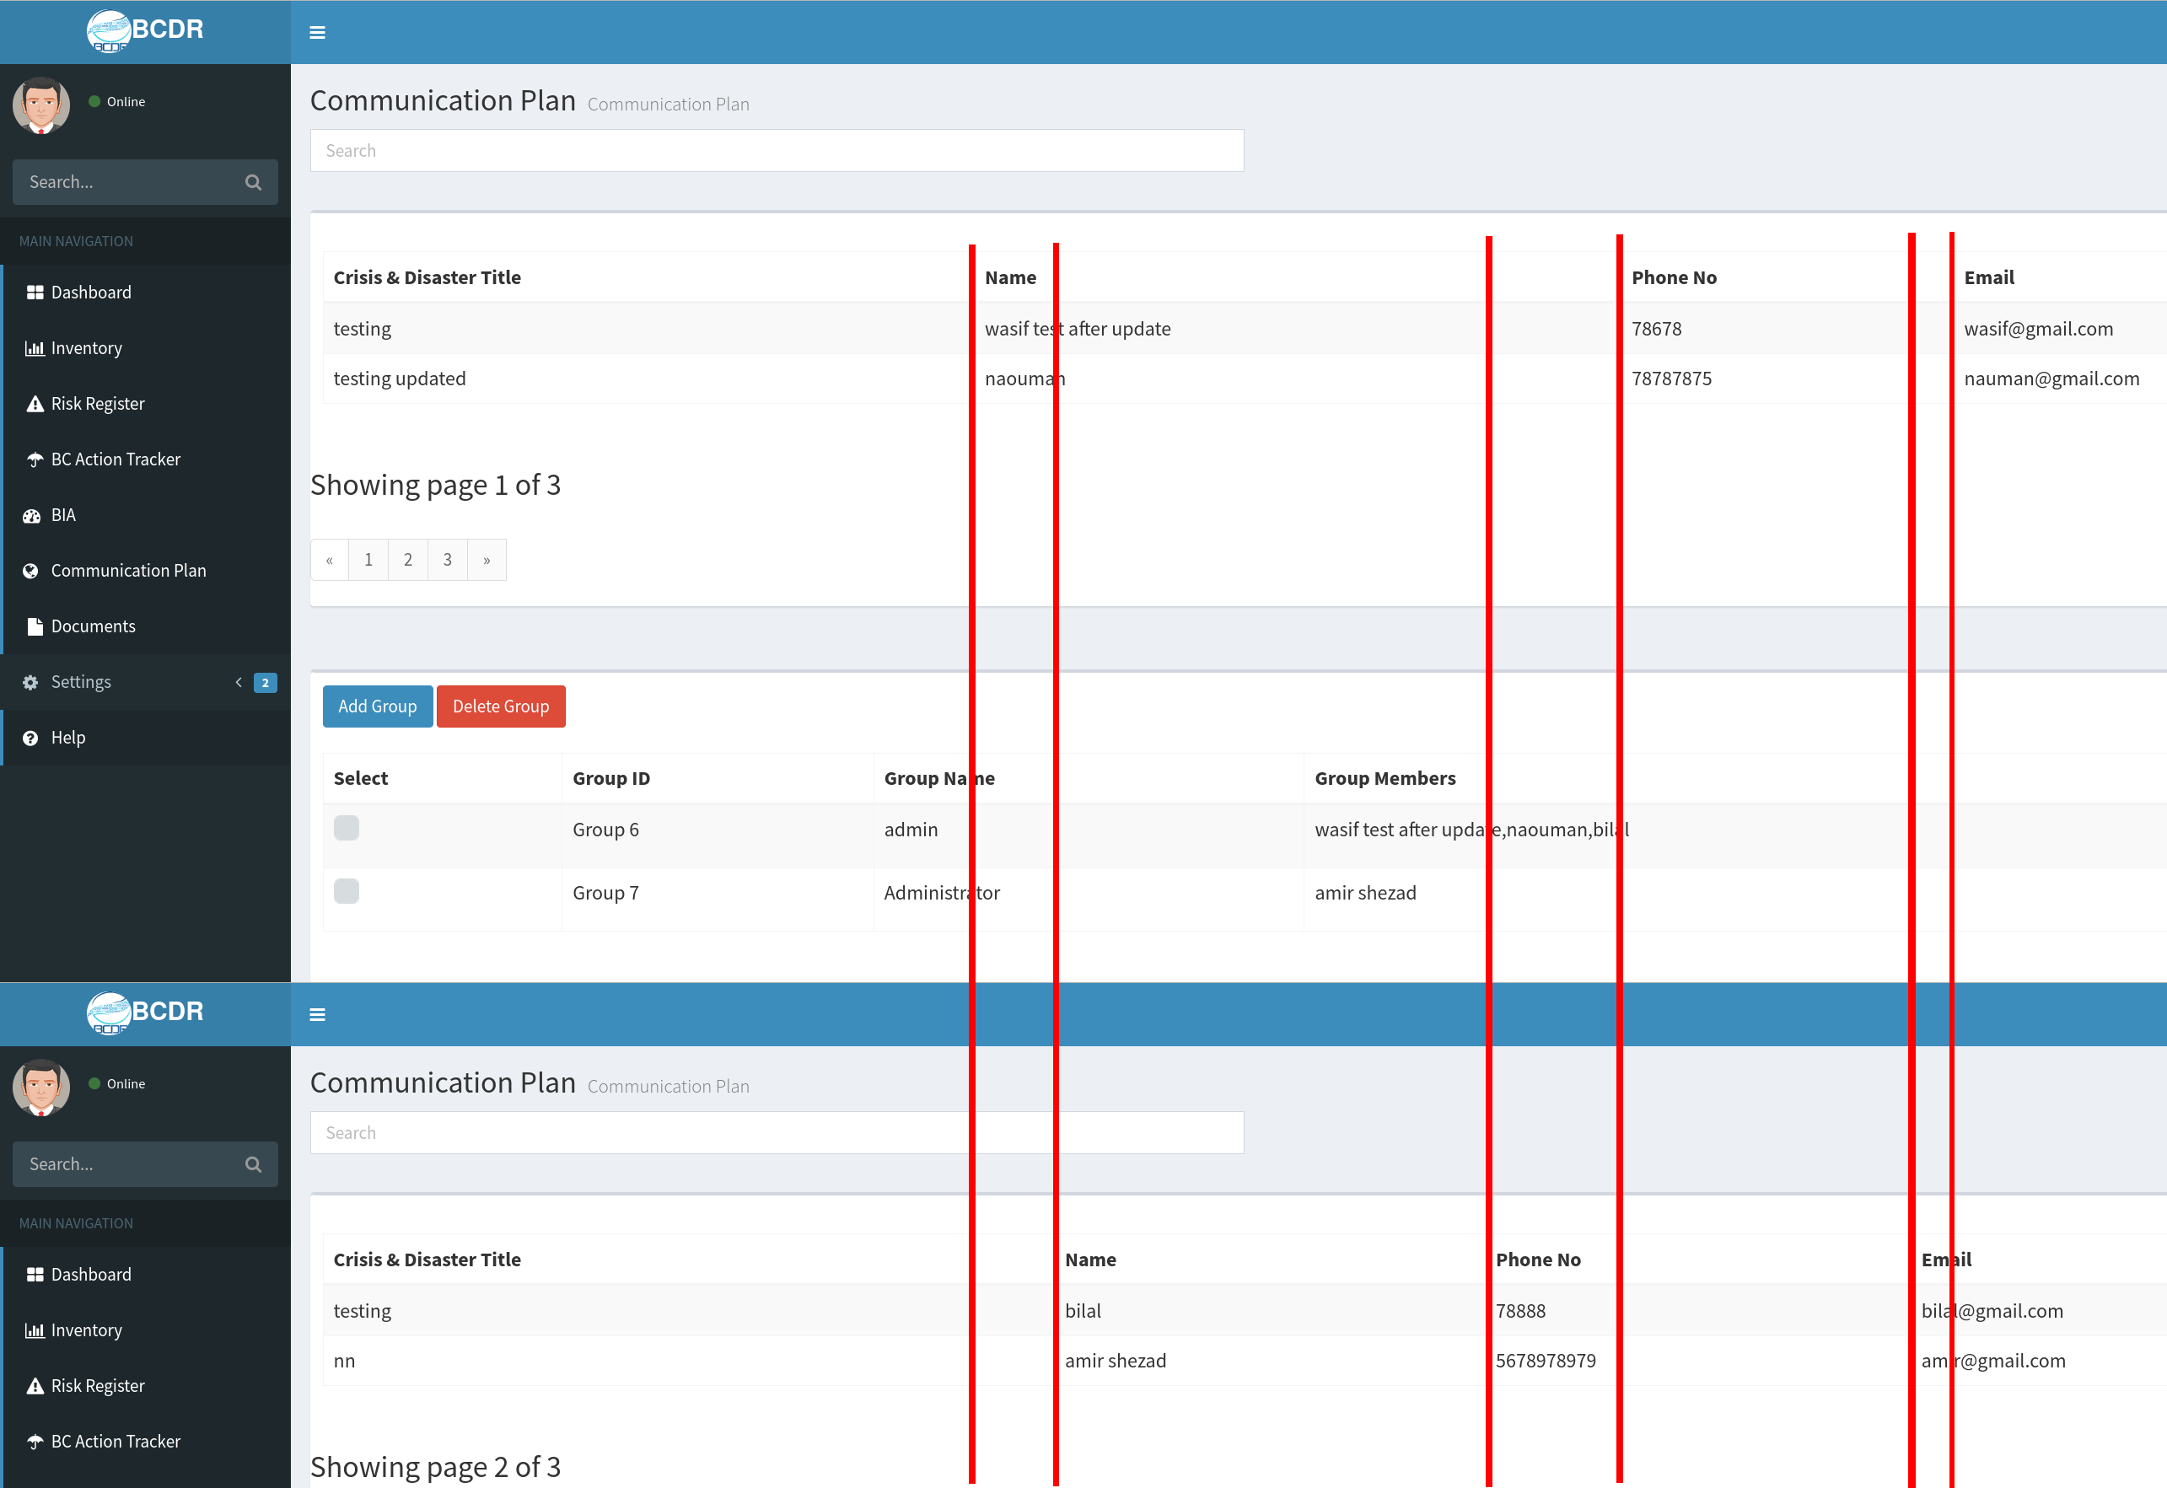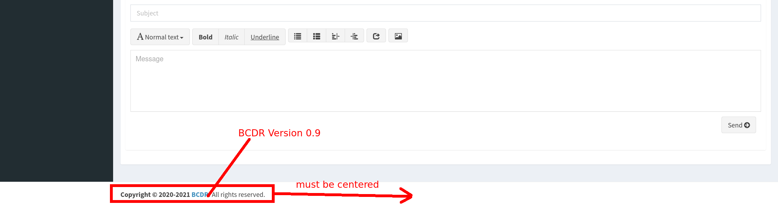

the number of characters should be not limited here at telephone number. This needs to be expanded because it means that mobile phone numbers in AT are not able to fill in correct at the moment.

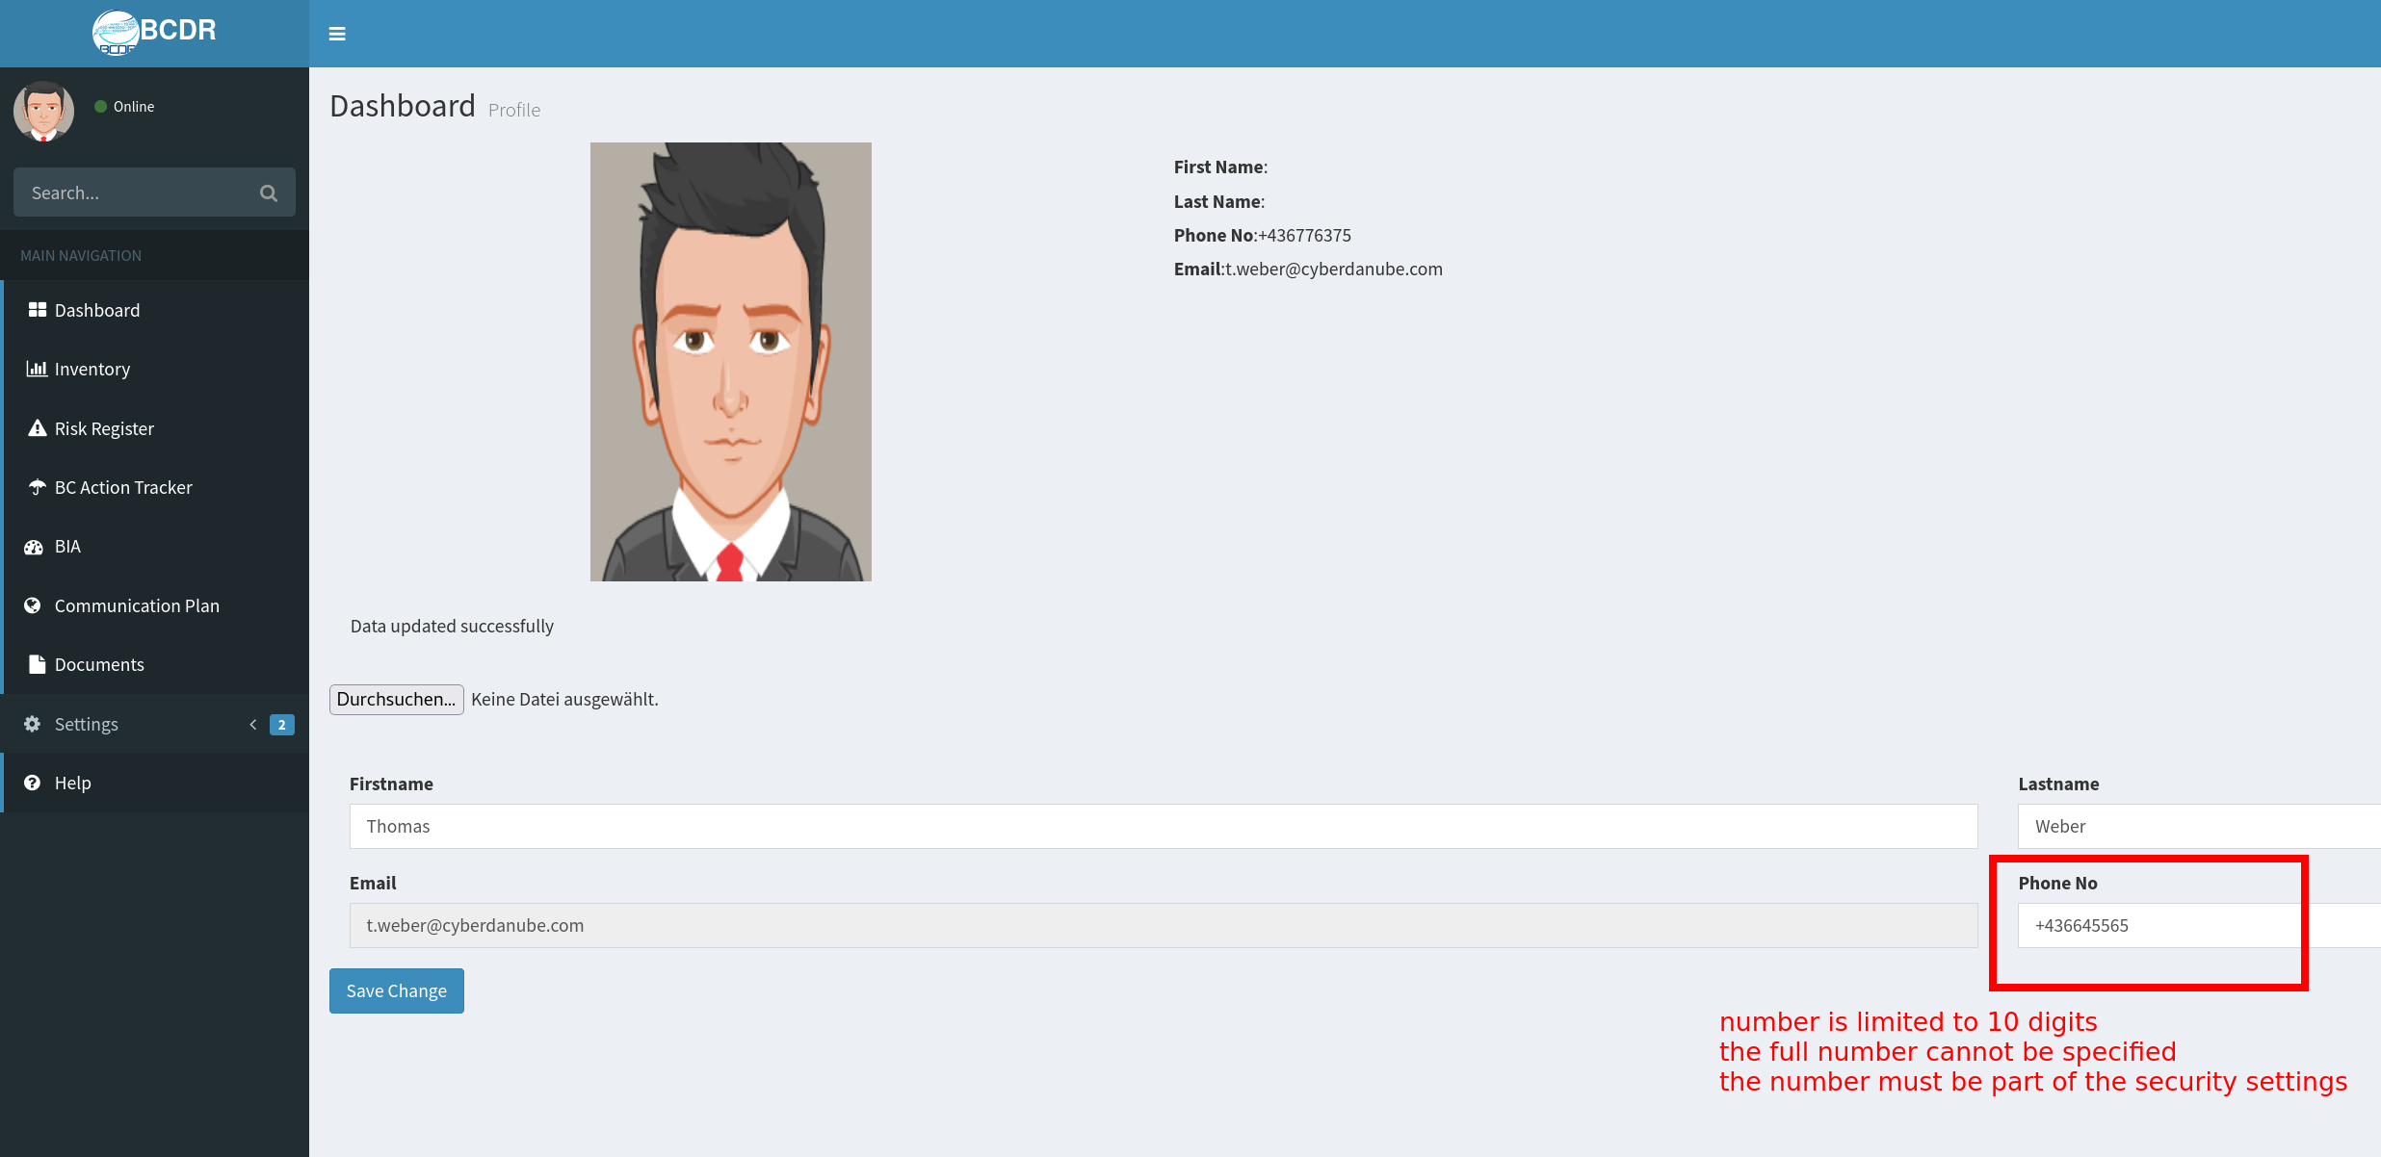

if a password is changed, the old password should also be requested. (password history)

Telephone number and password can only be changed if the old password is given correctly

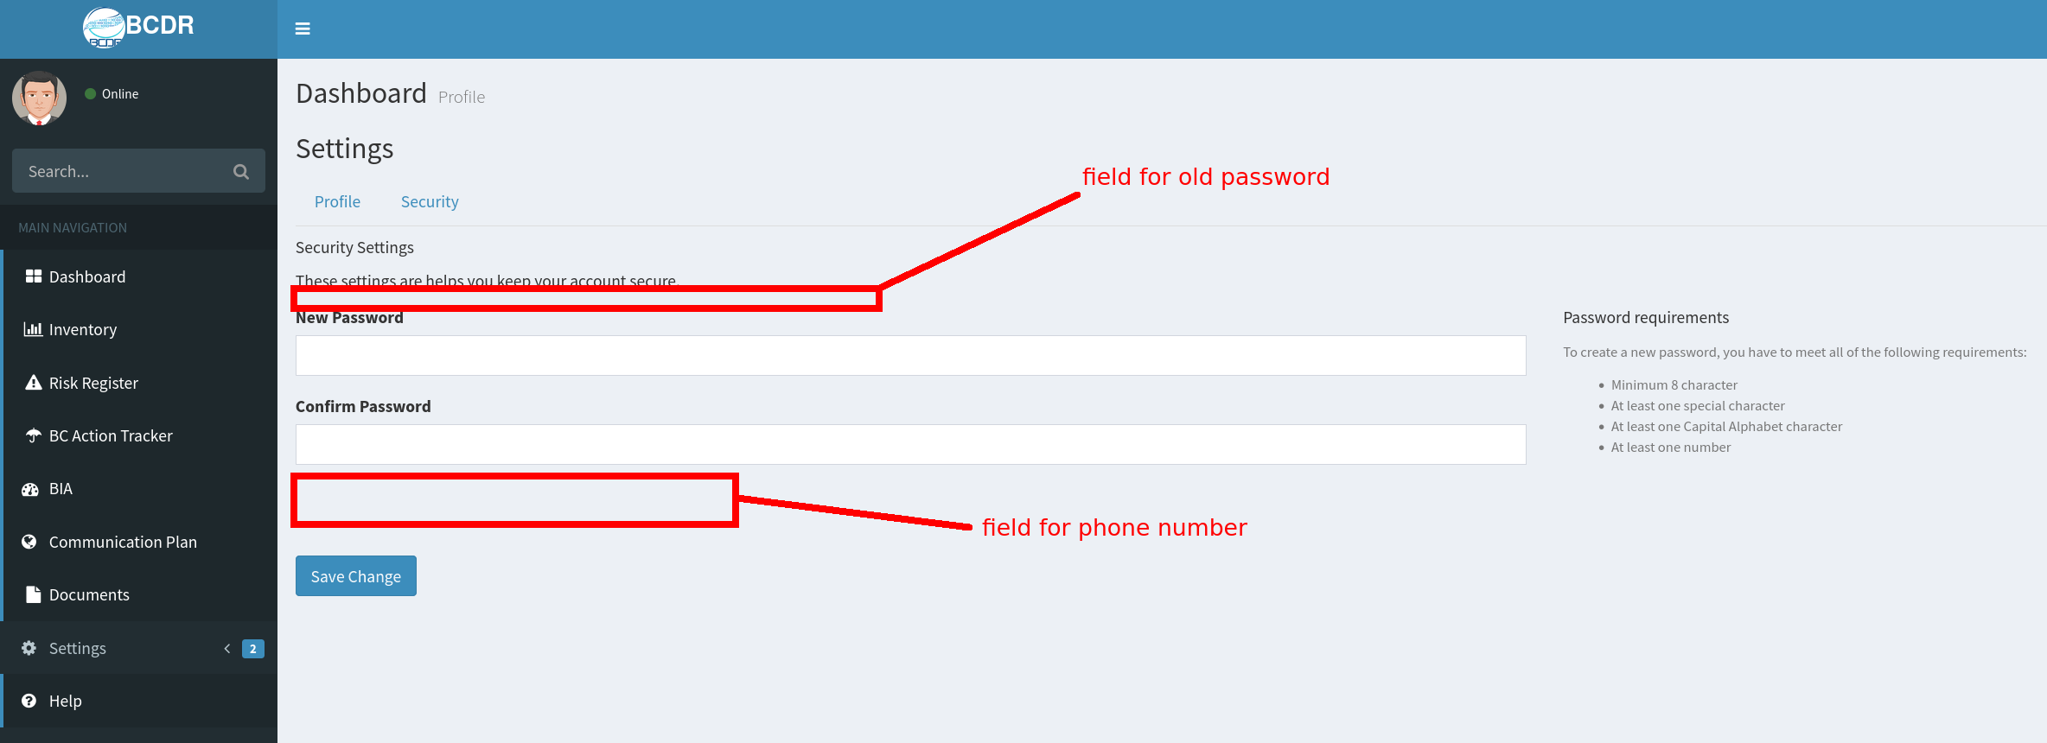

The probabilities and the impact should be checkboxes:

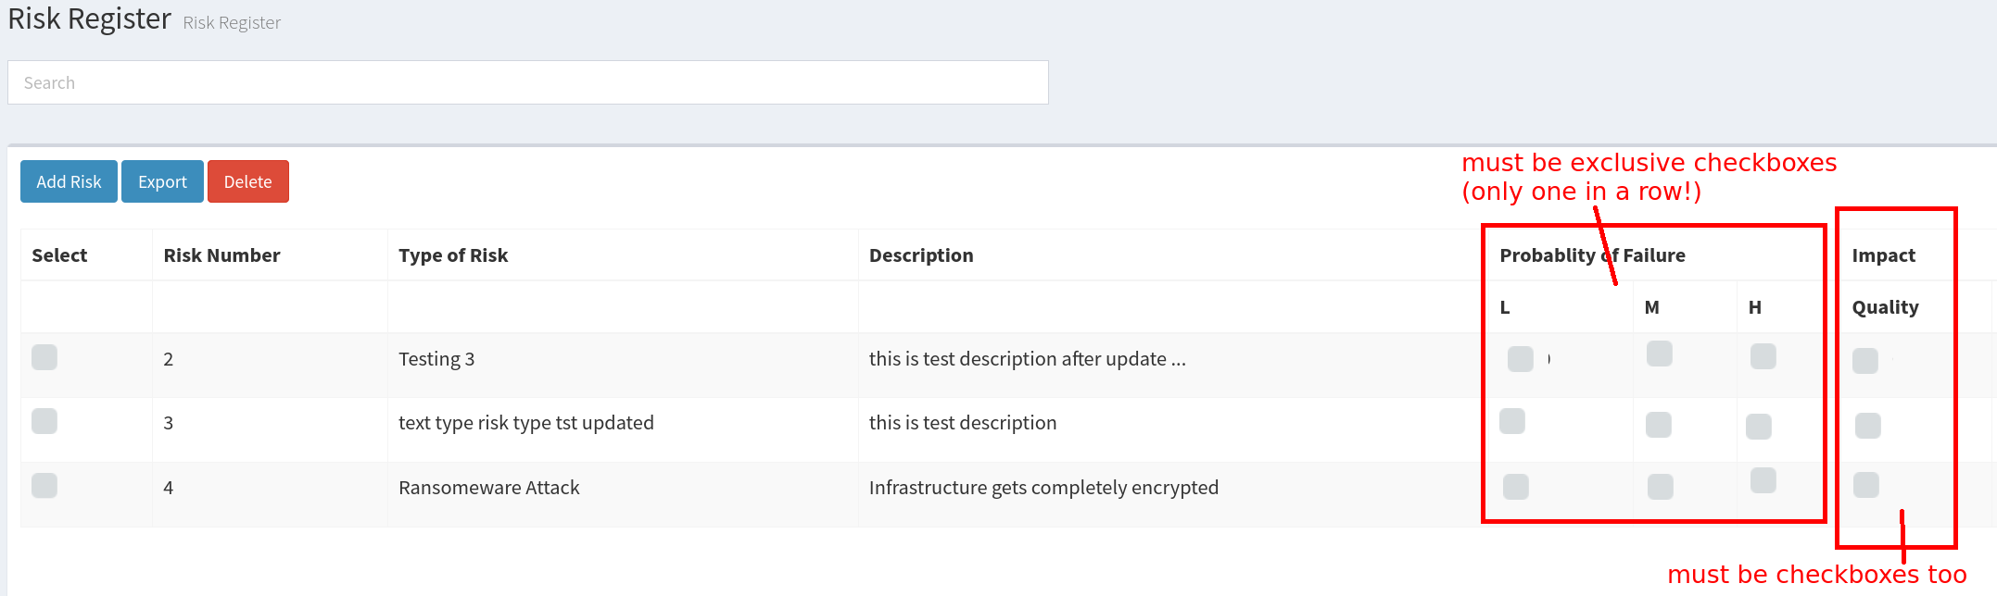

.

### Milestone 4

1. The files must be checked for their type when they are viewed. If they are not TXT, PDF or PNG/JPEG, the should only be downloaded.

Reference: <file:///C:/Users/adnan%20Rafique/Downloads/BCDR_Vulnerabilities.pdf>

1. 404 page, 502 page
2. Sorting, searching, custom pagination on all tables
3. Export button on all tables
4. API’s
5. Dashboard